Everyone who lives in the parish of Embsay with Eastby, or who has a connection with St Mary’s church in other ways, is welcome to have their funeral service here. The churchyard is also open for burials and interment of ashes, within current regulations.

The clergy are available to anyone living in the parish or connected with St Mary’s to conduct funeral services at the crematorium, or the funeral director’s parlour, or at a local cemetery.

This leaflet sets out the various statutory and local fees incurred for funerals and services of the clergy.
There is no charge for clergy time spent with you in preparing the funeral and supporting you afterwards. St Mary’s also commits to praying for you at this time and on the anniversary of the death.

Please also read this in conjunction with our leaflet on churchyard regulations, which gives more information on what is permissible for headstones, memorials and on-going care and maintenance.

Please ask if your specific requirements aren’t listed in the table of fees in this leaflet.
marion.russell@leeds.anglican.org
Tel: 01756 795625
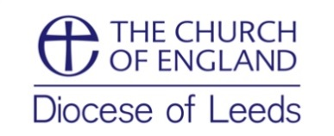
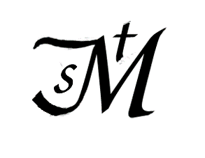

The Parish of St Mary the Virgin,
Embsay with Eastby

Guidelines for
Funeral Costs,
Churchyard Burials
and the
Interment of Ashes 2026

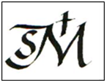
Churches and churchyards are sacred ground and very special places of
prayer, peace, tranquillity and beauty.

Vicar: The Revd Canon Marion Russell

2026
Standard costs for the church and clergy
Funeral service in church with organist, verger and heating then committal at crematorium or burial in local cemetery* | £440.40
Funeral service in church with organist, verger and heating, with burial in churchyard on the same day | £789
Funeral service in church, with organist, verger and heating, with burial of cremated remains in churchyard on the same day (where the body has previously been cremated) | £573
Service at crematorium* only | £248.40
Burial of cremated remains in churchyard on a separate occasion (without organist) | £206
Burial of body or cremated remains in local cemetery on another occasion* | £94.40

Bell-ringing minimum charge for 10 minutes plus £5 for every additional 5 minutes | £10.00 min

Additional Facilities Offered at St Mary’s
The costs in the tables opposite are statutory fees regulated nationally by the Church of England, along with local fees from St Mary’s where relevant. These are the totals that the Funeral Director will include in their invoice.
These are inclusive of
- clergy conducting the service and all preparation time with you
- right of burial where applicable,
- associated costs in the church, eg organist, heating and verger; where no organist is required, the overall cost will be less.
Please ask if you want a detailed costs breakdown.
The funeral director will also add the costs for the crematorium booking or for a sexton to prepare the ground for burial. Under some circumstances the sexton may be arranged through St Mary’s.
*burial or cremation at a cemetery outside Skipton or a service in a funeral parlour will add standard mileage charges for the minister conducting the funeral.
Please note there is no charge for the funeral or burial of a still-born infant or of a person dying within 18 years of birth.

